Spring IOC and DI:
@Component : this annotation we write on POJO or Java Bean class which is equal to <bean class=”com.bean.Employee”></bean>
@Autowired : This annotation we need to use on complex property level.
@Value : this annotation we can use on primitive property level to set default value
@Scope : this annotation on class level to set scope. By default scope is singleton.
@Configuration this annotation on class level. This annotation is equal to xml file
@ComponentScan : this annotation on class level. This help to enable @Component annotation

JDBC : Java Database connectivity : which help to connect any database using Java technologies.
ORM : Object Relation Mapping
Hibernate/JPA (Java Persistence API)
Spring JPA Data

@Component : on pojo or java bean
@Service : on service class which contains business method
@Repistory : on database layer using jdbc or orm or spring jpa data

Java side
JavaBean must be map to table

Spring core
Spring context
Spring Jdbc
Module

Project core Java project.

Web Project

We need server ie tomcat, web logic, jboss etc
We need do lot of configuration to create simple web application using spring MVC or spring web.

Spring boot : Spring boot is boot strap for all spring modules. With help of spring boot we can develop any type application very easily. Less configuration.

Spring boot = all spring modules – no xml file + few annotation + in build web server tomcat.
Spring boot provided lot of starter (spring boot starter)
Web starter
Jdbc starter
Jpa starter
Testing starter
Security starter
Etc.
These starter contains one or more than one dependencies which help to download n number of jar files in your projects.

Spring boot auto configuration. : base upon type of starter we added spring boot start default behaviour.

Spring boot project
Using maven : pom.xml file (is part of maven tool not a part of spring boot)
Using Gradle : no xml

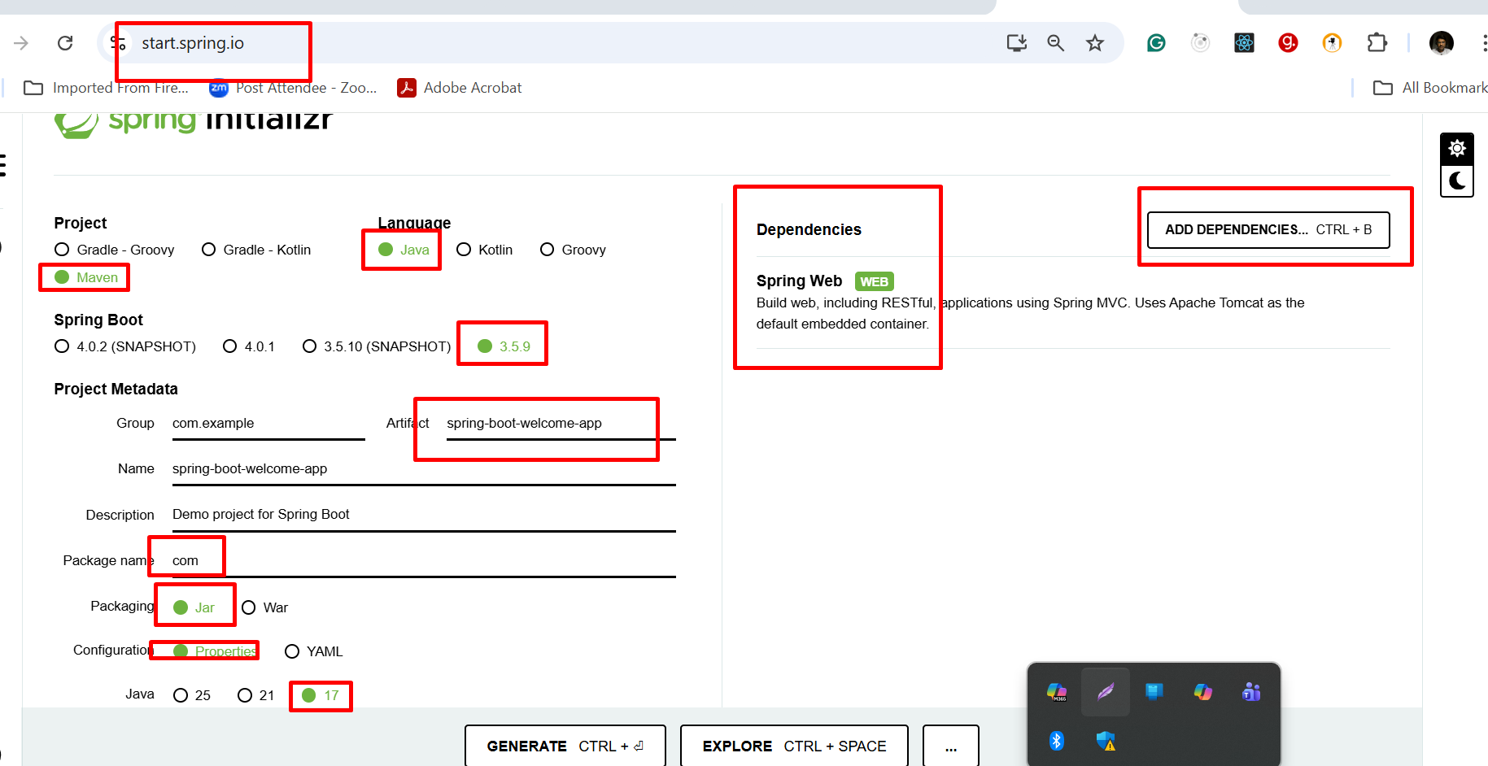

@SpringBootApplication = @Configuration + @ComponentScan + @AutoConfiguration

http://localhost:8080/

http://www.google.com:80

View --- In Core Java View is console. But web project view is HTML/JSP/Thymeleaf as View technologies(it is a like a html but dynamic html page) or other view technologies are present in spring boot.
I need spring boot must be create Rest full web service.

Creating another spring boot project with view as thymeleaf

